History
Depth Study 3: The Asian World
3a – Ancient India
Life Skills Stage 4 & 5, 7-10
Developed for St George School by Caroline Cass and Leah Ponzio supported by the Every Student, Every School Initiative. Adapted from the History Stage 4 Depth Study developed for Winmalee High School by Sara Korman, in a project funded by DEC HSIE Unit.

The School and Learning Context
St George School specialises in the provision of educational services for students with severe physical and multiple disabilities. Our school prides itself in being at the cutting edge of special educational provision for students with high support needs. The school develops personalised learning programs to maximise the potential of each student. Our school continues to investigate and trial better ways of delivering educational services and maintains prominence in the use of 'best practice' in special education.
The aim of secondary teachers, in implementing the Australian Curriculum, is to foster inquiry and engagement in History, providing rich authentic and engaging teaching and learning experiences that successfully support students with Intellectual and physical disabilities to engage with the curriculum on the same basis as other students.
Adjustments are measures or actions taken in relation to teaching, learning and assessment that enable a student with special education needs to access syllabus outcomes and content on the same basis as their peers. The types of adjustments made will vary according to the needs of the individual student.
With a wide range of abilities and learning needs pedagogy focuses on inclusivity and communication that informs programming and Formative Assessment strategies in History. While the mainstream stage 4 Ancient India program suggested by the DEC is of 8 week duration special educators will make adjustments based on the learning needs of their students.
This program has been designed for both students with high support needs (Teaching and Learning with Adjustments) and students with mild to moderate learning needs (Teaching and Learning with Scaffolding). Formative Assessment Strategies are embedded in all tasks that inform Assessment For Learning, and are structured towards Student Self Assessment as a empowering and critical thinking exercise.

Stage Four Depth Study 3a: Ancient India
Duration
11-12 lessons
Inquiry questions
- How, where and when did civilisations develop in ancient India?
- How did ancient Indians live, work and worship?
- How and why did the ancient civilisations of India change over time?
- How did significant individuals influence and shape life in ancient India?

Life Skills Outcomes

HTLS-1 Recognises personal connections to history
HTLS-2 Demonstrates an understanding of time and chronology
HTLS-3 Investigates how people lived in various societies from the past
HTLS-4 Explores features of a particular society or time
HTLS-5 Recognises the significance of people and events in the past
HTLS-6 Explores the significance of changes and developments of the past

HTLS-4 Explores features of a particular society or time
HTLS-5
HTLS-6
Historical Concepts
- Continuity and change
- Cause and effect
- Empathetic understanding
- Interpretation
- Influence and legacy (significance)

Historical Skills
- Analysis and use of sources
- Explanation and communication
- Research
- Comprehension of historical terms and concepts
Other Syllabus outcomes
English
Visual Arts
Geography
Mathematics
ICT

Content | Teaching and Learning with adjustments | Teaching and Learning with Scaffolding
Sequence One: How, where and when did ancient civilisations develop in India?  Student:  - describe the geographical setting and natural features of the ancient society  - explain how the geographical setting and natural features influenced the development of the ancient society | Lesson 1: Introduction to Ancient India  Make connections:  View the short video from “The Story of India” at http://www.pbs.org/thestoryofindia/.  Monitor: Students select photographs from a photo library (Photo gallery at pbs.org/thestoryofindia/gallery/photos) to describe ancient India. Students select appropriate written words that describe their pictures.  Lesson 2: Old and New  Provide students with a range of images of objects and words associated with ancient India and modern India. In small groups sort the images into old and new. Discuss.  In small groups or individually, students make a digital presentation; (SUGGESTIONS: Powerpoint, Pikochart, educreations, iMovie piccollage App for iPad)  Formative Assessment: Identifying and sorting Old and New  Old and New board & Old and New pictures Appendix 1  Student Self Assessment: How did I do today? Appendix 2  Lesson 3 & 4: Map of India  Display a map of modern day India (it is helpful to extend the map to include Pakistan). Include reference points that students may be able to identify, i.e. the Taj Mahal, The Himalayas, The Ganges, Mumbai (Bollywood). Provide students with a basic copy of this map.  Display a map of India that indicates the ancient civilisations of the Indus Valley. Students shade the area on their map and annotate the names of important ancient sites. During this activity the teacher explains that this area was the site of the first ancient civilisations in India.  www.mapsoftheworld.com/kids/  www.kbears.com  Google Search: Maps of world  Student Project: students use print resources and in internet to research the ancient city of Mohenjo Daro to create a postcard from the past or a clay sculpture.  http://www.mohenjodaro.net/mohenjodaroslides.html  Formative Assessment: Before you go what do you know? Appendix 3 | Make connections: Have students list words that they already associate with India.  View the short video from “The Story of India” at http://www.pbs.org/thestoryofindia/.  Monitor: Students select photographs from a photo library to describe ancient India. Students select appropriate written words that describe their pictures.  Lesson 2: Old and New  Provide students with a range of images of objects and words associated with ancient India and modern India. In small groups sort the images into old and new. Discuss.  In small groups or individually, students make a digital presentation; (SUGGESTIONS: Powerpoint, Pikochart, educreations, iMovie piccollage App for iPad)  Lesson 3 & 4: Map of India  Display a map of modern day India (it is helpful to extend the map to include Pakistan). Include reference points that students may be able to identify, i.e. the Taj Mahal, The Himalayas, The Ganges, Mumbai (Bollywood). Provide students with a basic copy of this map.  Display a map of India that indicates the ancient civilisations of the Indus Valley. Students shade  the area on their map and annotate the names of important ancient sites. During this activity the teacher explains that this area was the site of the first ancient civilisations in India.  www.mapsoftheworld.com/kids/  www.kbears.com  Google Search: Maps of world  Student Project: students use print resources and in internet to research the ancient city of Mohenjo Daro to create a postcard from the past or a clay sculpture.  http://www.mohenjodaro.net/mohenjodaroslides.html  Extension Activity: The teacher could develop a PowerPoint presentation on Mohenjo Daro, with images and text. Students then use the presentation to inform their postcards and sculptures.  Extension Activity: Visual Arts Clay Sculptures  Look at the clay sculptures of the Terracotta Warriors of China (ancient culture) and of the contemporary artist, Antony Gormley.  Appendix 8 for lesson ideas and pictures.
Sequence Two: How did ancient Indians live, work and worship?  Students:  - outline the main features of the social structures and government of the ancient society, including the role of law and religion  - describe the role of key groups in the society  - describe the everyday life of men, women and children in the society | Lesson 1: Indus Valley  Explore the BBC website. Introduce the topic of Ancient Indians in the Indus Valley.  www.BBC.co.uk/schools/primaryhistory/indus_valley/  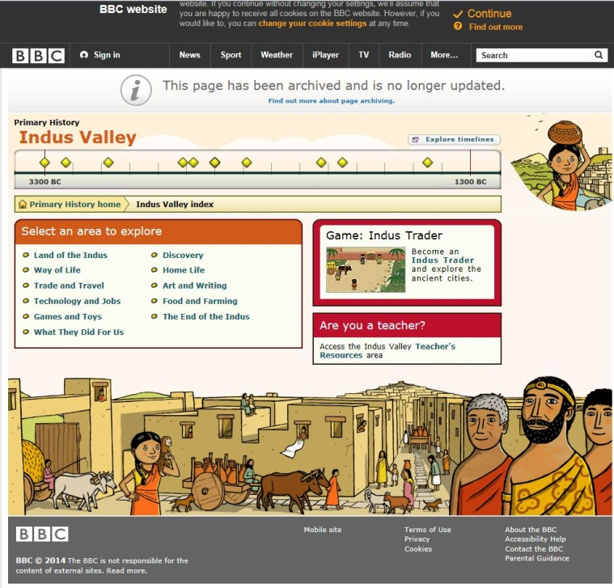  Lesson 2: How did the ancient Indians live?  Students view images of Indian clothing, textures, colours and designs.  Green Screen Project: using the green screen App on the iPad  Students source their preferred choice of image that shows a typical everyday image of ancient Indian life ie, market place, house, street scape, (See teacher info sheet attached Tips and Tricks for Green Screen.) Appendix 6.  Students dress up communicating choices and preferences. Students are videoed using the Green Screen App. Invite peers, family and class mates to a showing of their movies. Serve Indian snack foods while listening to Bollywood music.  Formative Assessment: Differences between Australian and Traditional Indian clothing.  Self Assessment Learning Log “I Like…” Appendix 4 | Lesson 1: Indus Valley  Explore the BBC website. Introduce the topic of Ancient Indians in the Indus Valley.  www.BBC.co.uk/schools/primaryhistory/indus_valley/  Lesson 2: How did the ancient Indians live?  Students view images of Indian clothing, textures, colours and designs.  Green Screen Project: using the green screen App on the iPad  Students source their preferred choice of image that shows a typical everyday image of ancient Indian life ie, market place, house, street scape, (See teacher info sheet attached Tips and Tricks for Green Screen.  Students dress up communicating choices and preferences. Students are videoed using the Green Screen App. Invite peers, family and class mates to a showing of their movies. Serve Indian snack foods while listening to Bollywood music.
Sequence Three: How and why did the ancient civilisations of India contact and conflict with other societies? | Lesson 1: Traders  Explore the BBC website and play the trader game.  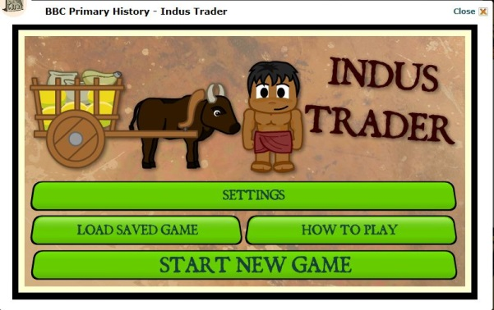  www.BBC.co.uk/schools/primaryhistory/indus_valley/  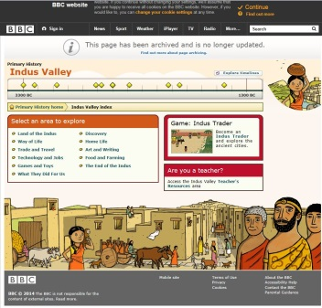  Students will become traders of their skills, stuff, space or time.  Teachers may want to refer to www.enviroweek.org  Students document their trading experience through film, photograph, sound or ICT presentation.  Lesson 2: The Spice Trade  Discuss the key spices that were traded through India.  Sensory experience: smell, touch, taste, create.  Collect a range of spices to smell, touch, taste. Students collect data on likes and dislikes of students.  Appendix 11 Like and Dis-like Picture communication symbols  Research spices from contemporary India and ancient India.  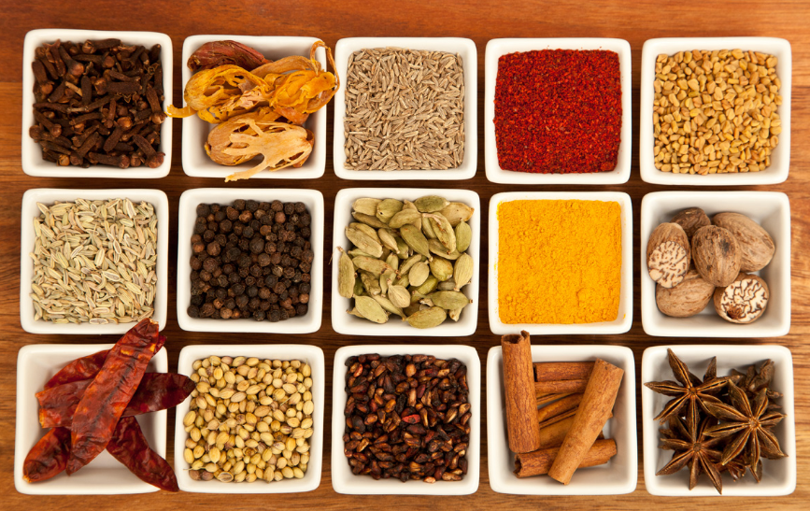  Choose a recipe that uses Indian spices. Read as a literacy text or make and enjoy.  Lesson 3: Making Connections  Explore an example of an important conflict and contact in Australia.  Resources:  - First Fleet04/02/14. Behind the News ABC. Children on the First Fleet. www.abc.net.au/btn/story/s3934600.htm  - National Museum of Australia. First Australians.  - Splash- abc. Native Title 200yrs in the making  - Splash- abc. Vincent Lingiari. A literacy text is Paul Kelly’s Song “From little things big things grow.”  Lesson 4: Making Johnny Cakes  St George School Students view the BOS Power point Johnny cakes.  (T/Curriculum/Literacy/Aboriginal Books Board of studies)  Students follow recipe and make Johnny Cakes.  Making Johnny Cakes  Formative Assessment: How did I do today? Appendix 5 | Extension: The teacher may also like to present students with examples of key spices that were traded through India and discuss their importance.  Spices Project;  Students investigate Spices. This might be by visiting a local spice shop and taking photos. Spices in this context may be in bulk quantities and this could be expanded into a maths project.  Or finding Spices and Spice mixes at the supermarket. Document all findings and prices.  Investigate recipes that use Indian spices.  Make a shopping list of items, purchase items and cook the spice recipe. Students might consider making a curry, an Indian tea called Chai, or an Indian dessert.  Create a menu, set a table and have a communal meal together.  Celebrating Festivals.  Using the website www.resources.woodlands-junior.kent.sch.uk investigate Festivals of India.  Practice the customary greeting by putting your hands together and with a slight nod to the head, say “Namaste”.  Diwali is the Hindu five day festival of lights that welcomes in the lunar new year. Investigate the Vivid Festival of lights that occurs in Sydney every year.  Investigate other Indian and Australian festivals. The Holi festival is the Colour festival for example.  Making Johnny Cakes  Students view the You tube clip  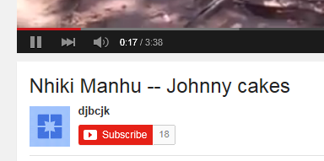  Students write down ingredients and make their own Johnny Cakes.  Formative Assessment: How did I do today?  Appendix 5
Sequence Four: How did significant individuals influence and shape life in ancient India?  • using a range of sources, including ICT, investigate the role of a significant individual in the ancient Asian world  • assess the role and importance of the individual chosen | Sequence Four: How did significant individuals influence and shape life in ancient India?  Research ONE significant person such as:  - Chandragupta Maurya, Ashoka, Budhayana, Aryabhata, Charaka, Patanjali, Siddartha Gautama.  Students research the individual and devise a mini  documentary (approx. 3-5 mins) of their life, achievements and legacy. The documentary can be created using the web tool Educreations (www.educreations.com), which allows students to add ‘voice-over’ commentary and annotate images  Once the presentations are completed students are to view presentations, complete the self assessment strategy.  At the conclusion of this unit of work students will be asked what they would like to learn more about  Formative Assessment:  I want to Learn more about? Appendix 6 | Sequence Four: How did significant individuals influence and shape life in ancient India?  Research ONE significant person such as:  - Chandragupta Maurya, Ashoka, Budhayana, Aryabhata, Charaka, Patanjali, Siddartha Gautama.  Students research the individual and devise a mini  documentary (approx. 3-5 mins) of their life, achievements and legacy. The documentary can be created using the web tool Educreations (www.educreations.com), which allows students to add ‘voice-over’ commentary and annotate images  For each presentation, students should develop a series of ‘Here, Hidden and Head’ questions (no more than 6 based on the information given) for their peers to answer. The last question is set by the teacher: “Based on the information you have been given, explain the importance of the significant individual to ancient India”.  Once the presentations are completed, in their small groups students are to view at least two other presentations, complete the questions and conduct a peer assessment review.  Peer Assessment strategy:  Two Stars and a Wish. Giving student feedback on student work. A student will give 2 gold stars to another students work for what they think is good, and a blue star as a suggestion for what could improve.

Final Student Assignment
Read the books about India on Tar Heel Readers (as at March 2015, there are two). Students select an aspect of their learning in Ancient India studies, and make a book on Tar Heel readers and publish this work. Books from tar heel Readers can be downloaded to the class computer or individual iPads.
Other options might be that students make a book to share with other students, and as an assessment of their own learning preferences on their iPads using Book Creator or another suitable app.

Formative Assessment:

Student Self assessment : ”What I liked most about this subject was…” Appendix 9

Peer Assessment: Two Stars and A Wish - Students read all the book presentations and give feedback on 2 things they think are great about each book. A blue star is given if students can identify an area of improvement.

Teacher Assessment: a Rubric provides students with clear guidelines for what is great work, what is ok and what needs improvement. Refer to Appendix 10 and modify for adjustments to student needs.

Resources
Literacy
Tar Heel Readers.com
Lighting a Lamp: A Diwali Story (Festival Time) by Zucker J.
I is for India (World Alphabets)
If you were me and Lived in…India: A Child’s Introduction to Cultures around the world (Volume 7 ) by Roman, C.
The Road to Mumbai by Jeyaveeran, R.
Websites
Resources.woodlands-junior.kent.sch.uk
Timeforkids.com India
Educational Virtual Museums http://christykeeler.com/educational virtualmuseums.html
Public Broadcasting service http://pbs.org/thestoryofindia/
pbs.org/thestoryofindia/gallery/photos
The British Museum www.ancientindia.co.uk
History for Kids http://historyforkids.org/learn/india
Moore teaching tips www.mooreteachingtips.com
Webtools:
Piktochart
Educreations
Green screen
iMovie
pic collage

Appendix List:
Appendix 1 Identifying and Sorting Old and New Template Appendix 1 Pictures
Appendix 2 Student Self Assessment: How did I do today? Appendix 2 pictures
Appendix 3 Student Self Assessment: Before you go what do you know? Appendix 3 pictures
Appendix 4 Student Self Assessment: Learning Log; “I like…”
Appendix 5 Student Self Assessment: How did I do today?
Appendix 6 Student Self Assessment: I want to learn more about…
Appendix 7 Tips and Tricks for Green Screen
Appendix 8 Art Lesson – Clay Sculptures
Appendix 9 Student Self Assessment: What I like most about this subject was…
Appendix 10 Teacher Assessment Rubric
Appendix 11 Like and Dis Like Picture communication Symbols

Appendix 1 pictures
How did I do Today?

Appendix 2 How did I do today

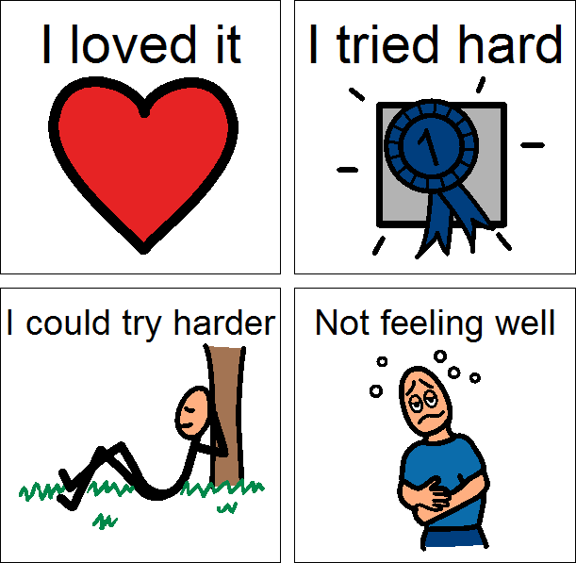
Appendix 2 How did I do today PCS
Appendix 3Appendix 4
Appendix 6
Tips and tricks for Green Screen
- You tube has helpful tutorials to introduce you to the Do Ink Green Screen App.

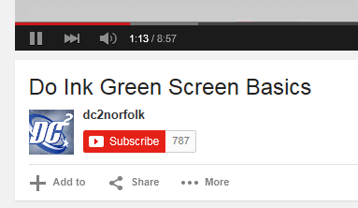
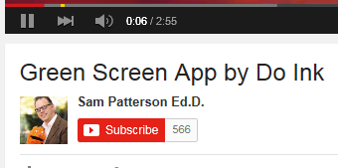

- Green screen is an excellent tool to create green screen videos on you iPad.
- The green screen effect works by combining images from 2 sources into a single image.

Tip 1: Use lime screen fabric for you green screen.
Tip 2: Hold the iPad steady while videoing to avoid the ‘floating’ effect.
Tip 3: be creative and have fun. The possibilities are infinite.

Appendix 7 Green Screen Tips
Appendix 8 Clay Sculpture lesson
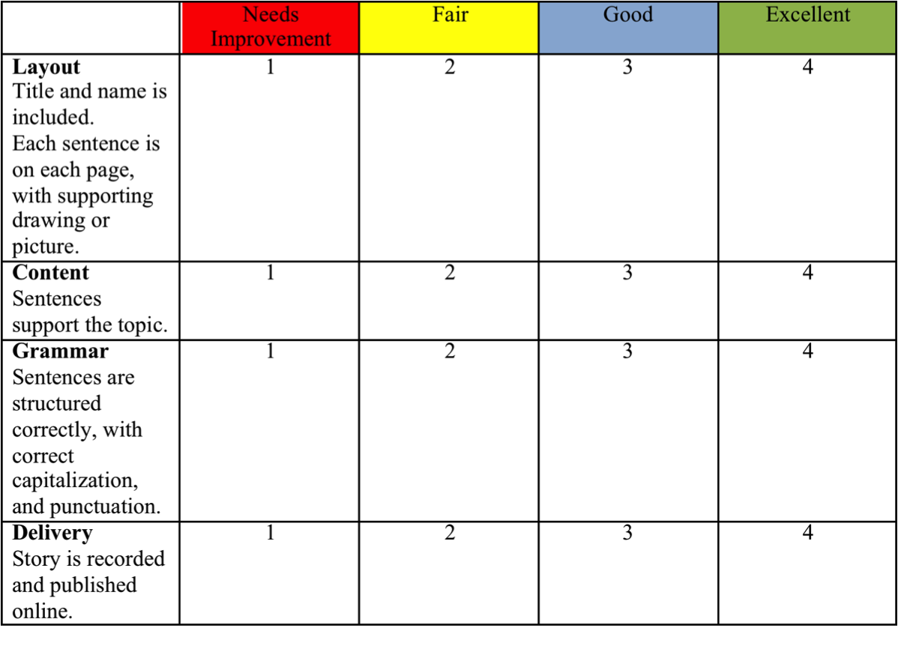
Appendix 10 Teacher Assessment Rubric

Like | Dislike
Appendix 11 Spices Data

