Magazine Program for Seniors
Recognising magazines and their content

 |  |  | 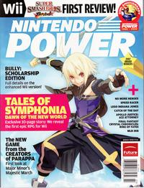
 | 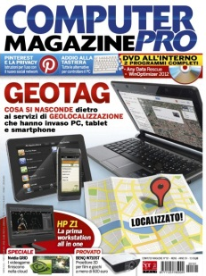
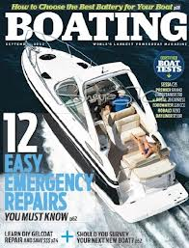 | 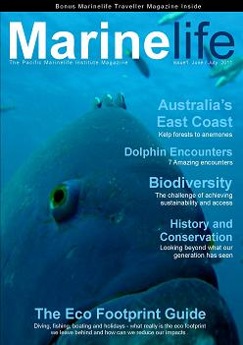
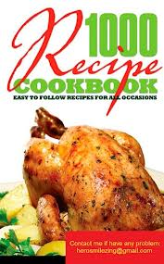

Copy twice and laminate to make a snap game from these cards

Use these cards to make a bingo game, you will need to copy and laminate a number of these

Use these cards to play content bingo
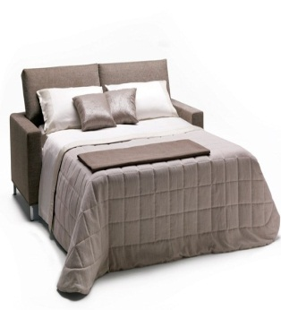 | 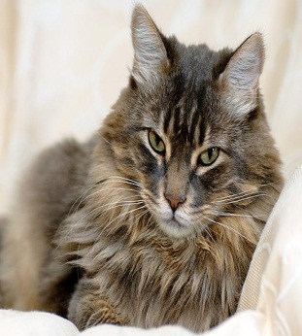
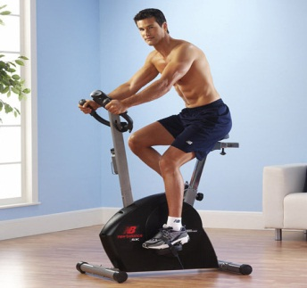 | 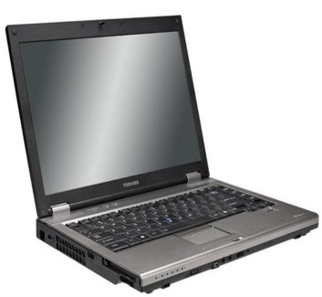
`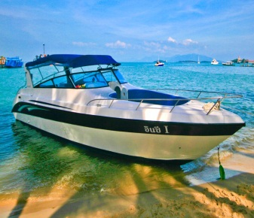 | 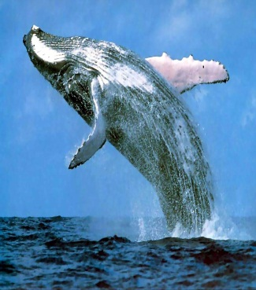 | 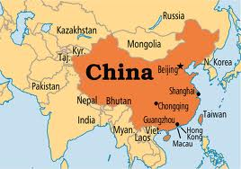
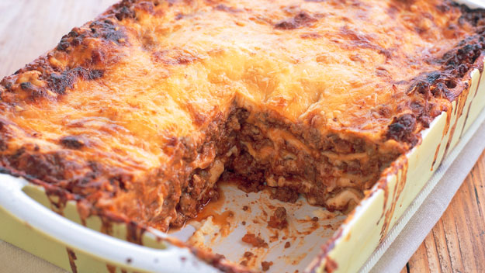 |  |  | 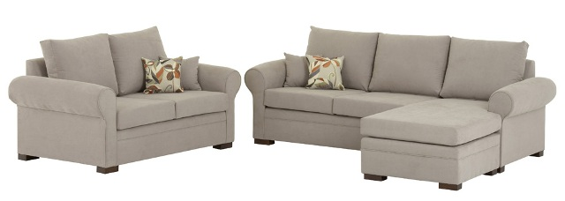
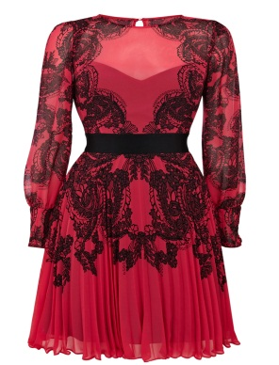 | 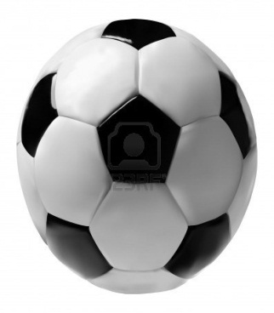 | 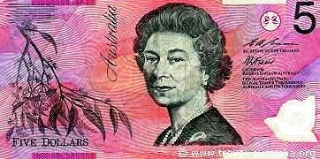 | 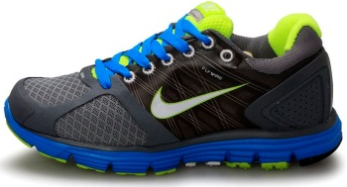

Use these as the board for the bingo game, each student has a board , recognises picture of magazine held by teacher, student says “me” if they have that picture on their board, first to fill card , yells “bingo”

Problem solving,
which magazine should student choose to find that which interests them.
Making a leisure choice
Games to encourage matching, getting on with peers, magazine recognition
- Magazine bingo
- Snap
- Use bingo cards with content subject on picture, yell “me” if have a magazine which would have that content
Make a magazine.. design and technology…
Maths how do you fit items of interest on one page
File away Alphabetise
Who likes what encourages talking and listening
Community access … purchasing magazines… where would you go to buy magazxine
Maths Vote and graph choices of magazines
How much are magazines
Change from different denominations of money
Choosing mag for specific purposes eg recipe
Cut and paste
KLA,s
Tas look up magazines on computer
Art Collage of different mags
All klas Make a picture using mags themed for eg make a bedroom, make a face eg angry make a recipe
English
Reading rules , Comprehension ,choices, writing,
Encourages friendships, students with like interests could sit together whilst looking at magazines… encourages talking and listening
Talking and listening, Answering questions eg.
If I want a holiday which magazine should I look at
Favourite mag literacy worksheets catering for all levels eg circling choices or writing a sentence about what you saw or liked
Types of magazines ,Favourite magazine

Outcomes
7-10
LS.1 | ENGLISH  Responds to auditory cues in a range of contexts
LS.5 | Recognises visual texts in a range of contexts
LS.6 | Uses visual texts in a range of contexts
LS.7 | Reads and responds to short written texts
LS.9 | Writes short texts for everyday purposes
LS.11 | Views and responds to a range of visual texts, media and multimedia
NLS.12 | MATHS  Reads and writes amounts of money
NLS.13 | Uses money to purchase goods and services
NLS.14 | Estimates and calculates with money
LS.11 | HISTORY  Uses a variety of strategies to locate and select information
LS.5 | PDHPE  Uses appropriate behaviours in social situations
LS.8 | VISUAL ARTS  Explores ways to develop ideas in artworks
LS 6.2 | DESIGN AND TECHNOLOGY  Participates in producing design projects
LS1.2 | INFORMATION AND SOFTWARE TECHNOLOGY  Uses a range of hardware

STAGE 6
SPEAKING
2.4 Answers questions and gives explanations:
2.9 Speaks with others in a range of formal and informal situations:
LISTENING
3.4 Listens to and responds appropriately to a variety of presentations in a variety of media:
READING
4.3 Recognises, interprets and responds to written information:
4.5 Comprehends and responds to a variety of texts in a range of formats to obtain information, engage in a range of recreation and leisure activities and undertake further education, training and employment:
WRITING
5.5 Writes to communicate information for a variety of purposes:
VIEWING
6.3 Views and interprets a range of media to access information and for leisure and recreation:
MATHEMATICS
5.4 Tenders amounts of money to make purchases, and estimates and calculates change:
5.1 Understands that money is a medium for purchasing goods and services:

ACCESSING TECHNOLOGY

1.2 Uses a range of both customised and widely available technology to facilitate learning and enhance daily living:
VISUAL ARTS
VALS 6 Makes a variety of artworks that reflect their experiences and responses or point of view
VALS 9 Makes an individual work or series of works using a range of materials, techniques and processes
PDHPE
3.4 Demonstrates awareness of the skills and personal qualities involved in initiating and maintaining relationships:
5.2 Demonstrates appropriate interpersonal behaviour while engaging in leisure activities:
5.1 Chooses and participates in a range of indoor and outdoor leisure activities:

Magazine rules
No tearing others want to read them 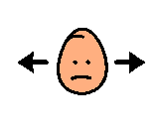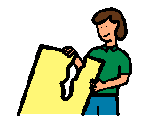

No magazines outside they will get destroyed 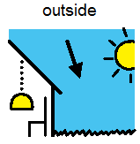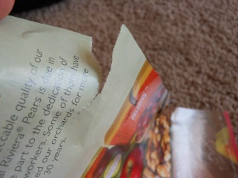
No magazines in mouth unhygienic
No drawing on mag because we share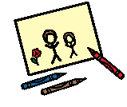
Place in right place when finished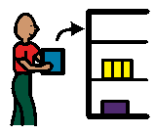
Ask for permission from teacher to cut magazines 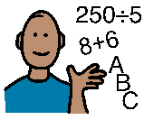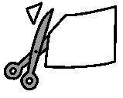

Magazine is $5.00
How much change do you need from a $10.00 note? Subtraction $10.00- $5.00= ??????
$5.00
Coins adding to $5.00
coins adding to $5.00
 | $5
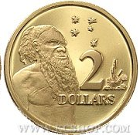 | $
 | $

Where would you find a picture of a bed
Find the right magazine so you can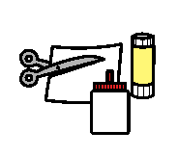 cut and paste a picture of a bed
Would you find a bed in a car magazine?
Circle the right answer o
yes no

Would you find a bed in a home magazine?
Circle the right answer o

yes no

cut and paste a bed
In which magazine should I look?

A________________________________

cut and paste an angry lady
In which magazine should I look?
A________________________________

cut and paste a house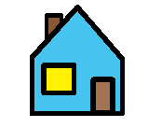
In which magazine should I look?
A________________________________

cut and paste a car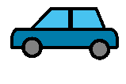
In which magazine should I look?
A________________________________

cut and paste a soccer ball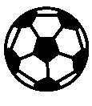
In which magazine should I look?
A________________________________

cut and paste a computer game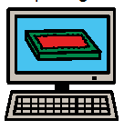
In which magazine should I look?
A________________________________

cut and paste a dress
In which magazine should I look?
A ____ ____________________________

