Online Literacy Programs
Online Maths Program | Description | Age Group  Suitability | Cost Involved
Studyladder | - Provides Maths resources, as well as English & science.  - Provides resources by grade.  - Provides tutorial, activities and assessment tasks.  - Allows teachers to set up class groups.  - http://www.studyladder.com.au/ | 4- 11yrs | Free  Need to login
TES | - Thousands of teacher-made resources.  - All curriculum areas.  - Has a special needs focus.  - Need to join to gain access.  - http://www.tes.co.uk/teaching-resources/ | All ages.  All students.  With special needs section. | Free  Need to login
TES Australia | - Created by TES – see above.  - Teacher made resources for all curriculum areas.  - Link to Australian curriculum.  - Has special needs focus.  - Need to join to gain access.  - http://www.tesaustralia.com/teaching-resources/ | All ages.  All students.  With special needs section. | Free, but must join.
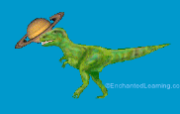  Enchanted Learning | - An American site.  - Resources for Maths and English, Science and Topic materials.  - Worksheets.  - http://www.enchantedlearning.com/Home.html | 4 – 11yrs | Free – some  Join online.
Copacabana  Public  School | - An Australian site – mainstream – Resources & Get smart sections.  - Provides resources for Maths and English, HSIE & Science.  - The resources are provided at other sites and this site links you to them.  - Linked to Australian curriculum outcomes.  - App available  - http://www.copacabana-ps.com/resources.html | 4 – 11 yrs | Free.
Starfall | - American website that has a few free resources.  - http://more2.starfall.com/m/welcome/first-demo/load.htm?www=first_grade& | 4 – 11yrs | Join online.
ABCYA | - American website.  - Provides free computer games and activities.  - Provides resources for Maths, English and Topics.  - http://www.abcya.com/ | 4 – 11yrs | Free
Senteacher | - American website  - Provides free resources for maths, English, science and social.  - http://www.senteacher.org/print/mathematics/ | 4 – 11yrs  Special  Needs  focus | Free
Very Special Maths  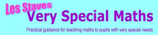 | - A Uk website.  - Articles on how to teach Maths to special needs.  - Practical suggestions.  - http://www.veryspecialmaths.co.uk/index.htm | Special  Needs  focus | Free
Help Kids Learn  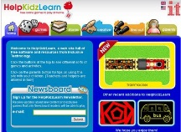 | - Great resource for early years/younger primary groups  - Have a basic story section – non text type.  - App available both android and ipads  - http://www.helpkidzlearn.com/ | 5yrs +  Focus on learning difficulties  And younger age group | Need to sign up $159 1 year subscription but can use some activities free on trial
Sparkle Box  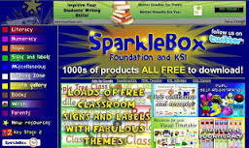 | - Resources based website  - Has a great Maths resource section to support a range of activities  - Also English, science and topics  - Downloadable and Printable resources for the classroom  - www.sparklebox.co.uk/ | K-6 | Free
Spectronics  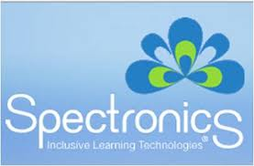 | - Teacher resource/information website for technology  - Excellent reference point for ipad apps for special education  - Professional development in the use of technology and literacy for specific students  - www.spectronicsinoz.com/  - http://www.spectronicsinoz.com/online/profile/apps-for-early-literacy-introduction/  - http://www.spectronicsinoz.com/online/resource/category/ipads-for-literacy-support/ | Learning Difficulties  Special Needs focus | Free but if you subscribe you have access to more prof development
Ian Bean  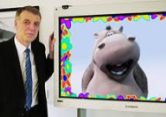 | - Teacher resource/information website for technology  - Free downloads – interactive activities  - http://www.ianbean.co.uk/ | Learning Difficulties  Special Needs focus | Free

