|  |  |
| --- | --- |
| NSW SCHOOL YEAR 2XXX | |
| Program: | Class:  Staff: |
| Day: | Time: |
| NSW Syllabus for the Australian Curriculum Outcomes: | |
| Individual student outcomes (including Life Skills Outcomes and adjustments and support):  All:  Most:  Some: | |
| Content: | |
| Lesson organisation, activities and strategies: | |
| Assessment - Content/Evidence: | |
| Language used: | |
| Resources: | |

|  |  |
| --- | --- |
| NSW SCHOOL YEAR 2XXX | |
| Program: Mathematics  Statistics and Probability: Data | Class: Early Stage 1  Staff: |
| Day: | Time: |
| NSW Syllabus for the Australian Curriculum Outcomes:  MAe-1WM Describes mathematical situations using everyday language, actions, materials and informal recordings.  Mae-3WM Uses concrete materials and/or pictorial representations to support conclusions. | |
| Individual student outcomes (adjustments and support):  All students will: Participate in discussion (using augmentative communication strategies if required) about the weather, assist in the collection of data each day and match weather visuals that are the same.  Most students will: Calculate the number of each weather condition and use information to complete a blank graph.  Some students will: Answer simple questions about the weather using the information in the graph and table. | |
| Content:  Determine if the weather is sunny or not sunny every day for a week.  Collect visual data on weather for a week through observation.  Tabulate collected data.  Complete a picture graph to represent the data collected for the week.  Answer simple questions about the weather. | |
| Lesson organization, activities and strategies:  Students view and discuss the visuals that will be used to describe the different weather conditions eg Is the weather sunny today? Y/N  Explain that we will take data for sunny/not sunny.  Discuss what ‘not sunny’ could mean (rain/cloud).  Students could complete a laminated matching activity for each weather condition.  For each day, students will record the weather at the same time eg just prior to home time each day.  Students will stick a laminated visual on a large class chart or on the interactive whiteboard.  At the end of the week students view their weather chart and count how many sunny/not sunny days. Record the totals in a simple table eg sunny = 3  Students stick visuals to create a simple picture graph.  Discuss how many of each weather type. Was there more sunny days this week? Was there more ‘not sunny’ days? | |
| Assessment-Evidence: Level of Support   |  |  |  |  |  |  |  |  | | --- | --- | --- | --- | --- | --- | --- | --- | | Content | FP | PP | V | VS | M | GS | I | | Match weather visuals that are the same on a laminated puzzle |  |  |  |  |  |  |  | | Identify weather icons sunny/not sunny |  |  |  |  |  |  |  | | Stick appropriate weather visual on a chart each day for a week |  |  |  |  |  |  |  | | Write total number of each weather condition in a simple table |  |  |  |  |  |  |  | | Stick sunny/not sunny visuals on a simple picture graph |  |  |  |  |  |  |  | | Identify whether there was more/less sunny/not sunny weather that week |  |  |  |  |  |  |  | | |
| Language used:  Sunny/not sunny, cloudy, rainy, weather, how many?, the same, different, observe, total, table, equals, picture graph, more than, less than, collect, information, data, | |
| Resources:  Sensory resources to represent different weather conditions eg water sprayer for rain  Large and small visuals depicting sunny/not sunny eg. Internet pictures, Boardmaker symbols (see appendix)  Cardboard for large class chart  Large numerals to stick onto chart  Laminated weather matching puzzles (see appendix)  Interactive table/picture graph on notebook software  Large cardboard and visuals for class picture graph  Small picture graph structure and visuals to stick on | |

|  |  |
| --- | --- |
| NSW SCHOOL YEAR 2XXX | |
| Program: Mathematics  Statistics and Probability: Data | Class: Stage 3  Staff: |
| Day: | Time: |
| NSW Syllabus for the Australian Curriculum Outcomes :  MA3-1WM Describes and represents mathematical situations in a variety of ways using mathematical terminology and some conventions. | |
| Individual student outcomes (adjustments and support):  All students will: Participate in discussion about the weather (using augmentative communication strategies if required), assist in the collection of data each day and match weather visuals that are the same.  Most students will: Calculate the number of each weather condition and use information to complete a blank picture graph.  Some students will: Answer questions about the weather using the information in the graphs and table. | |
| Content:  Collect data on weather conditions for a week through observation.  Tabulate collected data.  Complete a column graph to represent the data collected for the week.  Interpret information about the weather using tables and graphs. | |
| Lesson organization, activities and strategies:  Students view and discuss the visuals that will be used to describe the different weather conditions.  For each day, students will record the weather at the same time eg just prior to home time each day.  Students will stick a visual on both a large class chart and record in a personal chart (see Boardmaker resources) each day.  At the end of the week students view their weather chart and add up the total number of each weather icon. Record the totals in a simple table eg sunny = 4  Discuss the number of each weather type. Which had the most? Which had the least?  Present the students with a picture graph labelled and completed. Provide them with Boardmaker visuals for each of the weather conditions. Students match the visuals to the graph to complete it.  Present students with an almost completed version. Provide students with Boardmaker visuals and help them refer to their table to stick the correct number of visuals for the week.  Use a ruler to trace around the graph and create block shaped columns. Cut out the graph as a whole and trace the outline onto card. Look at the shape of the graph now. Eg if sunny had the highest representation then it will show the longest column.  Discuss: Looking at the picture graph and column graph outline discuss how each shows the same information. | |
| Assessment: Evidence Level of Support   |  |  |  |  |  |  |  |  | | --- | --- | --- | --- | --- | --- | --- | --- | | Content | FP | PP | V | VS | M | GS | I | | Match weather visuals that are the same on a laminated puzzle |  |  |  |  |  |  |  | | Identify weather icons sunny, rainy, windy, stormy, cloudy ….. |  |  |  |  |  |  |  | | Stick appropriate weather visual on a chart each day |  |  |  |  |  |  |  | | Write total number of each weather condition in a simple table |  |  |  |  |  |  |  | | Match weather visuals to complete a simple picture graph |  |  |  |  |  |  |  | | Place the correct number of weather visuals in each column on a picture graph |  |  |  |  |  |  |  | | Identify the prevalent weather condition for the week |  |  |  |  |  |  |  | | |
| Language used:  Graph, table, chart, observe, collect, sort, compare, more than, less than, groups, row, column | |
| Resources:  Sensory resources to represent different weather conditions eg water sprayer for rain  Large and small visuals depicting different weather conditions eg. Internet pictures, Boardmaker symbols (see appendix)  Cardboard for large class chart  Large numerals to stick onto chart  Completed and blank picture graphs  Laminated weather matching puzzles (see appendix)  Tracing paper and markers to trace columns over the picture graph  Scissors | |

|  |  |
| --- | --- |
| NSW SCHOOL YEAR 2XXX | |
| Program: Mathematics  Statistics and Probability: Data | Class: Stage 5  Staff: |
| Day: | Time: |
| NSW Syllabus for the Australian Curriculum Outcomes:  Stage 5 Outcome: MA5.1-12SP  Uses statistical displays to compare sets of data, and evaluate statistical claims made in the media. | |
| Individual student outcomes (adjustments and support):  7-10 Life Skills: MALS-35SP: Recognises data displayed in a variety of formats.  All students will: Participate in discussion about the weather (using augmentative communication strategies if required), assist in the collection of data each day and match weather visuals that are the same.  Most students will: Calculate the number of each weather condition and use information to complete a blank graph.  Some students will: Answer questions (with appropriate supports eg visuals) about the weather using the information in the graphs and table. | |
| Content:  Recognise data displayed in different ways, eg, a table and graph to show daily conditions. | |
| Lesson organization, activities and strategies:  Students view a table depicting the weather conditions for the previous four weeks.  (Accurate data taken from www.bom.gov.au)  Discuss the meaning of each of the weather icons to establish understanding of what each means.  Students add up the total number of each (ie sunny/rainy/cloudy/windy/stormy) and fill in a simple table to show the total of each weather type over four weeks.  Students are then presented with a variety of graphs showing the same information from the table they have been studying eg. Pie chart, bar graph, pictogram.  Students to use the graphs and the original table to answer a series of questions about the weather for that month. | |
| Assessment: Evidence  Students recognise and describe weather icons for sunny, rainy, windy, stormy, cloudy.  Students can look at a given pie chart, bar graph and pictogram and identify the most and least common weather condition for the month.  Students can recognise that the data in each chart or graph means the same thing, even though it is represented in different formats.  Students correctly answer simple and inferential questions about the weather in an activity sheet.  Level of Support   |  |  |  |  |  |  |  |  | | --- | --- | --- | --- | --- | --- | --- | --- | | Content | FP | PP | V | VS | M | G/S | I | | Identify weather icons sunny, rainy, windy, stormy, cloudy ….. |  |  |  |  |  |  |  | | Identify the most common weather condition for the month |  |  |  |  |  |  |  | | Identify the least common weather condition for the month |  |  |  |  |  |  |  | | Recognise that the data in each chart or graph depicts the same information |  |  |  |  |  |  |  | | Correctly answer simple questions about the weather for the month |  |  |  |  |  |  |  | | Correctly answer more complex questions about the weather for the month |  |  |  |  |  |  |  | | |
| Language:  Graph, table, chart, observe, collect, sort, compare, more than, less than, groups, row, column | |
| Resources:  Large and small visuals depicting different weather conditions eg. Internet pictures, Boardmaker symbols (see appendix)  Calender page for a month of accurate weather observations eg March (see appendix)  Accurate information from relevant weather websites  Blank table for students to write the total of each weather condition (see appendix)  Completed graphs reflecting the information from the table (pie/column/picture)  Laminated weather matching puzzles (see appendix)  Weather analysis question sheet (see appendix) | |

Appendices

Boardmaker visuals to copy and paste

Examples of tables and graphs to create

|  |  |  |  |
| --- | --- | --- | --- |
|  |  |  |  |
|  |  |  |  |

7

6

5

4

3

2

1

Sunny Cloudy Rainy Windy



|  |  |
| --- | --- |
|  |  |
|  |  |

Weather Analysis

C:\Program Files (x86)\Microsoft Office\MEDIA\CAGCAT10\j0293828.wmf

1. What month was the weather recorded?

…………………………………………

1. How many days in the month are there?

………………………………………

1. How many Sunny Days were there?..........
2. How many Rainy Days were there?...........
3. How many Cloudy Days were there? …………….
4. How many Stormy Days were there? ……………
5. How many Windy Days were there? ………………
6. Were there more Sunny than Rainy Days? ………………..
7. Why do you think there were more/less sunny/rainy days this month?.....................................
8. Was the weather the same this time last year? ……………………………
9. What might the weather be like this time next year? …………………………………………….

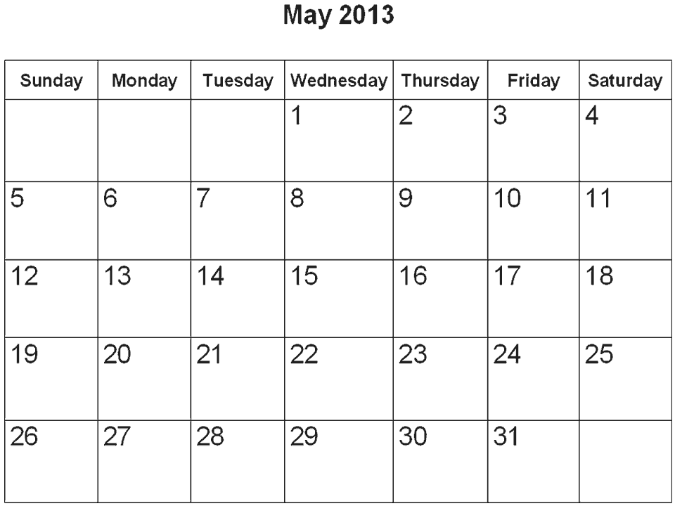



**Weather for March**

**Sunny Cloudy Rainy Windy Stormy**



Create a Graph site – I used this to create above graphs used in the Stage 3 Lesson.

[www.nces.ed.gov/nceskids/createagraph](http://www.nces.ed.gov/nceskids/createagraph)

***Additional links to useful webpages and examples of resources:***

Downloadable data handling word mat

<http://www.sparklebox.co.uk/previews/8276-8300/sb8294-data-handling-word-mat.html>

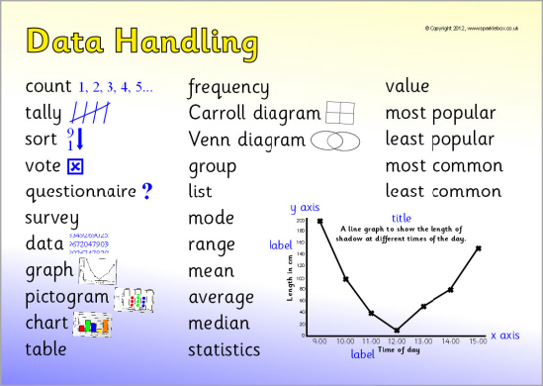

Downloadable images for weather survey and pictogram

<http://www.sparklebox.co.uk/4731-4740/sb4739.html>

Year 3 data handling pack (there are Year 4 and 5 also)

<http://www.sparklebox.co.uk/6771-6780/sb6773.html>

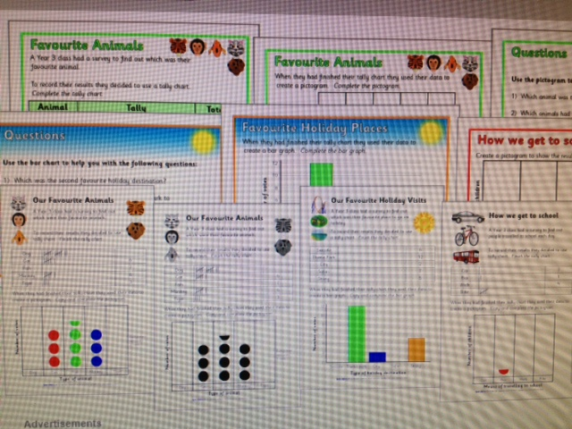

Downloadable data resources such as simple class surveys, pictograms, vocab

[www.sparklebox.co.uk/maths/data-handling](http://www.sparklebox.co.uk/maths/data-handling)

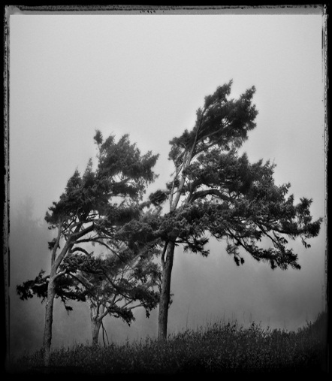

**Images copied and pasted from Google Images**