- STUDENT PROFILE

Who is …………? Date:
What does he / she need to learn and why.

Likes | To be completed in term one to identify priorities  To be completed in term 4 to communicate with next teacher
Dislikes
Communication
Receptive
What he / she needs to learn and why
Communication
Expressive
What he / she needs to learn and why
Social
What he / she needs to learn and why

Living Skills
What he / she needs to learn and why
Sensory needs
Classroom rules and routines
What he / she needs to learn and why
Academic
What he / she needs to learn and why

Likes and Dislikes | 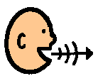  Communication | Danger
 | Likes | Dislikes

Do this | Strategies for behaviour
When  you see  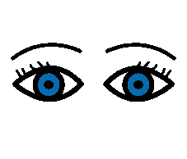  this | Behaviours you might see
Do this | Preferred way of interacting with/supporting the student to keep them calm/settled

